API
- / (UI)
- /[service]
- /rpc

Features 特征
UI A dashboard to view and query running services
Proxy A reverse proxy（反向代理） to micro web services (includes websocket support)

Proxy
Micro Web has a built in HTTP reverse proxy for micro web apps
The proxy will use /[service] along with the namespace (default: go.micro.web) to 在服务发现中查找服务. It composes service name as [namespace].[name].
The proxy will strip剥离 /[service] from the request and forward发送 the rest of the URL Path to the web app. It will also set the header “X-Micro-Web-Base-Path” to the removed path incase you need to use it for some reason like constructing URLs.
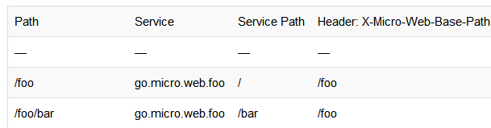

开始使用
运行Web UI/Proxy
micro web
默认使用ACME 通过letsencrypt提供安全
micro --enable_acme web
（可选）指定主机白名单
micro --enable_acme --acme_hosts=example.com,web.example.com web
Web代理支持使用TLS证书安全地进行服务
micro --enable_tls --tls_cert_file=/path/to/cert --tls_key_file=/path/to/key web
Web默认提供命名空间go.micro.web。命名空间和请求路径的组合用于解析服务以反向代理
micro web --namespace=com.example.web

统计
You can enable a stats dashboard via the --enable_stats flag. It will be exposed on /stats
micro --enable_stats web

